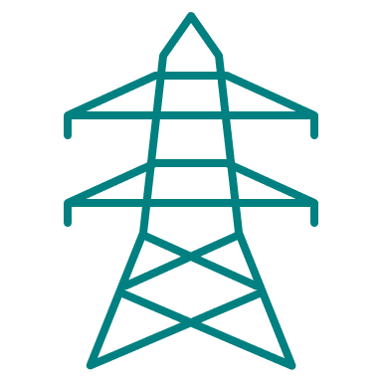


Grid Capacity Review

A final report of the Place & Resources Scrutiny Committee Task & Finish Group inquiry

January 2024



Contents
1. Introduction 3
2. Background to the review 4
3. What is the grid? 5
4. How the is grid changing? 9
5. How are constraints managed? 12
6. How are constraints forecast? 13
7. How does network investment work? 16
8. What are the constraints locally? 17
9. What are the primary challenges? 20
10. Implications and recommendations 32
Appendix: 1: National policy and regulatory reform 35

Introduction
  - The energy crisis threw into sharp relief the challenges posed by the UK’s lack of energy self-sufficiency. This strengthened national ambition to transition from volatile and costly fossil fuel imports towards an energy system that is cleaner, more secure, and more affordable. We are consequently amid a period of major change for the UK’s energy system.

  - Government’s overarching ambition is to decarbonise electricity by 2035. Major progress has already been achieved, but there remains a considerable way to go. It will require deployment and delivery of energy infrastructure at an unprecedented pace and scale.

  - It is widely acknowledged, however, that traditional processes, policy and regulation are not suited to this challenge. A range of barriers are commonly highlighted, including constrained grid capacity, planning and regulatory consenting processes, energy markets, and global competition for investment to name just a few.

  - Discussion typically centres on renewables. Yet the future energy system requires not just cleaner ways of generating energy, but fundamental changes to how we store, transport, supply and use it.

  - In particular, there is a fundamental challenge to ensure that the UK’s ‘creaking’ grid is itself fit for purpose to accommodate new low carbon generation and storage assets – alongside the significant growth in demand for power from the electrification of heat and transport. Shortcomings in the system have already yielded a heavily constrained grid that has failed to keep pace with the pace of new generation and demand. This is yielding lengthy delays to attaining connections, and costing connecting customers and bill payers alike.

  - The challenge cannot be understated: grid constraints are now commonly cited as the single biggest barrier to decarbonising power. But if unaddressed its strategic significance is broader, presenting a drag not just on decarbonisation and energy security, but also on business expansion, development, investment and economic growth. Solving it, however, could unleash benefits for households, communities and the economy alike.

  - This is not just an issue for the future. Local projects already face delays, curtailment or cancellation owing to prohibitive connection costs or grid strengthening delays – and in some cases it has impaired project viability entirely. Many local stakeholders have reported being offered connection times as late as 2036.

  - As this report outlines, however, this is thankfully now an area of significant ongoing national reform – particularly across 2022, 2023 and 2024. Government, Ofgem and industry have each begun setting out significant new policy, regulation, and processes over the last couple of years.

  - Consequently, this is an opportune point to subject the issue to extended scrutiny, and to examine how we can best mitigate any risks and best exploit emerging opportunities locally. Whilst much of the reform is at the national scale, there is a clear prospect for the council to play a strengthened role in influencing the emerging new energy system for the benefit of Dorset.

  - This report presents the findings of the Place and Resources Scrutiny Committee inquiry into the impacts, challenges and opportunities of grid constraints and associated reforms. It introduces the key terms, roles, processes, and policies necessary to understand the problems and opportunities, including:
- The confluence of factors – more decentralised supply, new technologies, major demand growth, and more complex balancing through wider use of flexibility tech – that are prompting the need to reform how the grid is governed, built, and managed.
- The programme of reform, such as on strategic planning and investment, connection queuing and charging, and electricity and flexibility markets.
- A set of recommendations for the council resulting from the issues outlined.

  - The following report is written both to record the findings and recommendations of the review, but also to serve as a primer on the issues in recognition of the technical and likely unfamiliar nature of the subject matter.

Background to the review
  - The Places and Resources Scrutiny Committee determined in May that a task and finish group should be established to review the issue of grid constraints and produce a set of recommendations. The overall objectives were threefold:
- Growing understanding and awareness of the issues to enable better engagement and advocacy.
- Gathering further evidence from key stakeholders on the local impacts and possible solutions.
- Strengthening links with network operators and forming a wider view on how the council could best mitigate the risks and exploit the opportunities for Dorset.

  - The review was specifically focused on electricity grid constraints. There are of course a much wider set of related energy system issues such as regards the deployment of renewables and storage assets, the deployment of low carbon technologies like EV chargers and heat pumps, electricity suppliers and bills, gas networks, and hydrogen – but full examination of these wider matters was outside of the scope of the review, except where they had relevance to grid constraints specifically.

  - The inquiry was structured into five sessions which took place in from October 2023 to January 2024, and was timed to coincide with the expected announcement of major national reforms from Government and Ofgem.

  - The task and finish group was Chaired by Cllr Shane Bartlett, and also comprised Cllr Andy Canning, the late Cllr Tony Ferrari, Cllr Brian Heatley, Cllr Carole Jones, Cllr Robin Legg, Cllr Robin Tooke, and Cllr Kate Wheller. The group was supported by the Sustainability Team, the Corporate Director for Strategy, Performance and Sustainability, and the Corporate Director Economic Growth and Infrastructure.

  - The five sessions comprised:
- Session 1: A background introductory briefing on key terms, roles, and processes.
- Session 2: Evidence from council officers on the impact of constraints on council programmes.
- Session 3: Evidence from local stakeholders on the impact of constraints in Dorset beyond the council.
- Session 4: Evidence from grid stakeholders.
- Session 5: Review of findings and recommendations
Those sessions were complemented by desktop research on the reform programme that emerged during the process.

  - Through the sessions the group heard evidence from a wide range of participants, including council officers from our sustainability, estates, planning and transport teams; Dorset Council’s Cabinet; and externally from Regen and the South West Net Zero Hub; large and small scale renewables developers; retrofitters; EV chargepoint installers; public sector partners; community energy initiatives; high energy-using businesses; economic development representatives; housing developers and housing associations; and network operators. The inquiry is extremely grateful to all the participants for their time and insights.

What is the grid?
  - The electricity grid is the network of infrastructure responsible for carrying power from where it’s generated to the point of consumption by a home or business. It comprises a system of overhead lines, underground cables and substations.

  - Most electricity has traditionally been generated at large power plants and generators, which was then transmitted and distributed via the grid to where it is consumed or stored.

  - There are two types of network which make up the two halves of the grid:
- The transmission network is the high voltage network that carries energy long distances from major large-scale generators to local area substations. Nationally this includes around 18,000km of cabling and a network of substations and other transmission assets which are owned, built, and maintained by the Transmission Owner.
- Distribution networks are the lower voltage networks that then carries electricity for the final part of its journey to homes or businesses. Nationally this includes around 800,000km of cabling and a network of substations and other transmission assets which are owned, built, and maintained by Distribution Network Operators.

  - The transmission network is akin to the network of motorways (high speed, long-distance), whilst the distribution is akin to network local highways (lower speed, shorter-distance). The two are bridged by grid supply points, which convert high-voltage electricity from the transmission network to a lower voltage so that it can be safely distributed to end users.

  - Power is stepped down from high to low voltage in multiple stages through different kinds of substation on its journey to homes and businesses:
- Grid Supply Points convert to 132Kv
- Bulk Supply Points convert to 66kV or 33kV
- Primary Substations convert to 11kV
- Distribution Substations convert to 400 or 230 volts, for use by household electrical devices.

  - There are physical limits to the amount of power that can be transmitted or distributed through a given piece of infrastructure – limits which are set to ensure that the equipment doesn’t overheat or become overloaded. As equipment approaches its safe capacity, it is considered ‘constrained’ – meaning that it can start to act as a bottleneck in the network. This doesn’t necessarily mean that it’s at full capacity, and it may be unproblematic for some projects – but it can start to limit what it is possible to connect. Resolving this problem may prompt ‘reinforcement’ works that expand the asset’s capacity.

  - Building and maintaining the grid can involve a wide mix of activities, such as designing assets or extensions, cable or substation installation, cable jointing, trench digging, excavation and duct installation, and landowner negotiations.

  - The main operational stakeholders responsible for undertaking this work of building, owning, operating, and maintaining the grid are:
- The Transmission Owner (TO), which builds, owns and maintains the national transmission network. That role is fulfilled by National Grid Electricity Transmission (NGET).
- The Energy System Operator (ESO), which manages and plans the supply and demand balance on the network to ensure that it is stable and secure. In England that role is fulfilled by National Grid ESO (a separate company from NGET).
- Distribution Network Operators (DNOs) which build, own, maintain and operate the distribution network in 14 geographical areas throughout Great Britain. There are 6 DNOs nationally.
- Independent Distribution Network Operators (IDNOs), which can build, own, maintain and operate local networks for new developments anywhere, in competition with DNOs.
- Independent Connection Providers (ICPs), which are accredited companies that can build networks by undertaking specific ‘contestable’ works on behalf of a DNO or IDNO.
- The Energy Networks Association (ENA), an industry body representing network operators and providing a platform to collaborate on reform, co-development and alignment of new processes and products.

  - This system is governed by government and the regulator:
- The Department for Energy Security and Net Zero sets the policy and legislative framework.
- Ofgem sets the common regulatory framework and monitors compliance of all those listed above. This means that it determines licenses for those companies, and sets incentives, duties and penalties – as well as being responsible for dispute resolution (e.g. between network operators and connecting customers). It also sets the ‘price control’ framework which determines how much companies can charge customers, and thereby the amount available for grid investment.

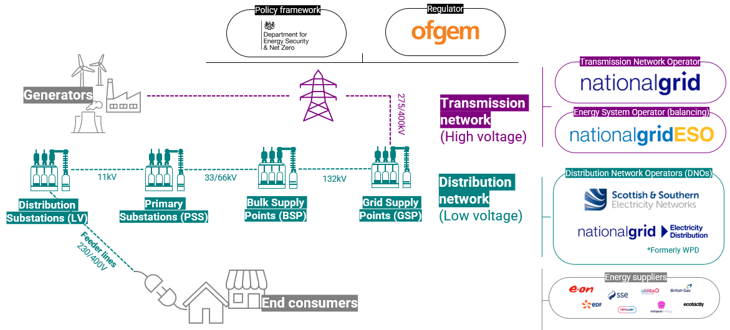
Fig 2. The grid and key stakeholders
  - National Grid Electricity Transmission (NGET) builds, owns and maintains the transmission network nationally, including the transmission infrastructure that serves Dorset directly. Dorset overlaps two DNO areas: the Southern area licensed to Southern and Scottish Energy Network (SSEN), and the South Western area licensed by National Grid Electricity Distribution (NGED). Those license areas extend far beyond Dorset (SSEN’s, for instance, covers 53 local authorities). Most of Dorset’s local distribution network falls within SSEN’s area, except for a small area in West Dorset managed by NGED.

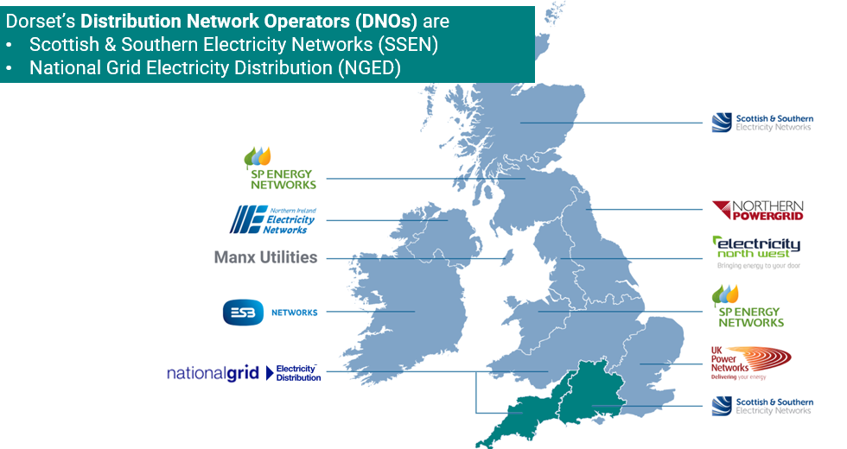
Fig 1. DNOs in the UK and Ireland
  - Network operators are not electricity suppliers. Suppliers are distinct companies which buy electricity from the wholesale market and sell it onto consumers, so are effectively an intermediary between consumers and the grid. Whilst network costs are paid by all consumers through electricity bills (as outlined below), most consumers do not interact with network operators directly.

  - Direct interaction with network operators is typically undertaken only by those customers seeking to obtain a new connection to the grid, such as for renewables, a new development or to install an EV charger. Not all connections require an application in advance, only those over a certain threshold – as smaller assets can connect under ‘connect and notify’ rules that only require the network operator to be notified once they are installed. Connections agreements can be sought for both new generation or demand assets; and they are made with the network operator, who sets out the details of the connection, charges and terms & conditions.

  - Whilst most new connections don’t presently do so, connection requests may also require (or ‘trigger’) an upgrade or ‘reinforcement’ to be made to the network to ensure that there is adequate capacity for the new connection. Reinforcement costs can be significant; but vary project to project and are contingent on factors like the size of the connection, its location, and its distance from the existing network. Generally, therefore, areas with spare capacity are quicker and cheaper to connect to. A connection offer will usually be made if one is sought, but the issue for connecting customers is whether it is viable to do so given any attendant delays or costs.

  - Ofgem regulates connections pricing and service quality through license conditions and its quality of service guaranteed standards. When a new connection is sought, the network operator must offer to do so at some price – and the initial request for the offer has no upfront charge. DNO licenses set conditions for the handling of connection requests.

How the is grid changing?
  - The scale and significance of constraints is growing due to changes in what is required of the grid. To decarbonise power and electrify transport and heat, new sources of supply, storage and demand will need to be connected to the grid, and the existing network will need upgrading to absorb the increase in power flow. There are three central dimensions of change: decentralisation, demand growth and flexibility.
Decentralisation:
  - Traditionally power generation has occurred remotely from large settlements, and the grid was designed for electricity to flow one way from a centralised source through a top-down system.

  - But increasingly generation is becoming much more decentralised and power is flowing back up the network (Figure 3). This is in due to the connection of many more local generators which are plugging directly into the distribution network (what are known as ‘embedded’ generators) – like commercial or community-owned renewables, or those installed on homes like rooftop solar panels – as well as forms of electricity storage (including potentially EVs) that can export power back into the network.
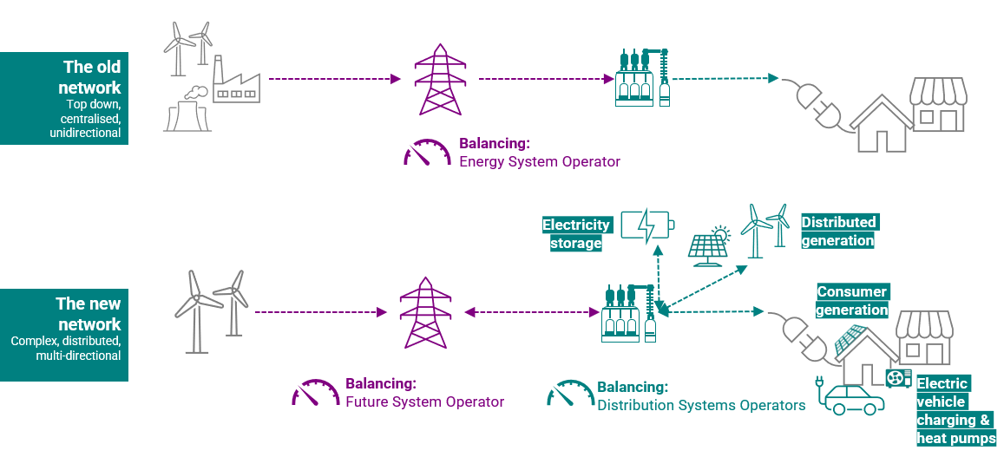
Fig 3. Decentralisation
Demand growth:
  - Demand for electricity is expected to double to 2050, mostly due to the electrification of heating, transport and sections of industry. The magnitude, speed and composition of that growth depends on modelling assumptions, but an indicative forecast of the Climate Change Committee’s central scenario is shown in Figure 4.
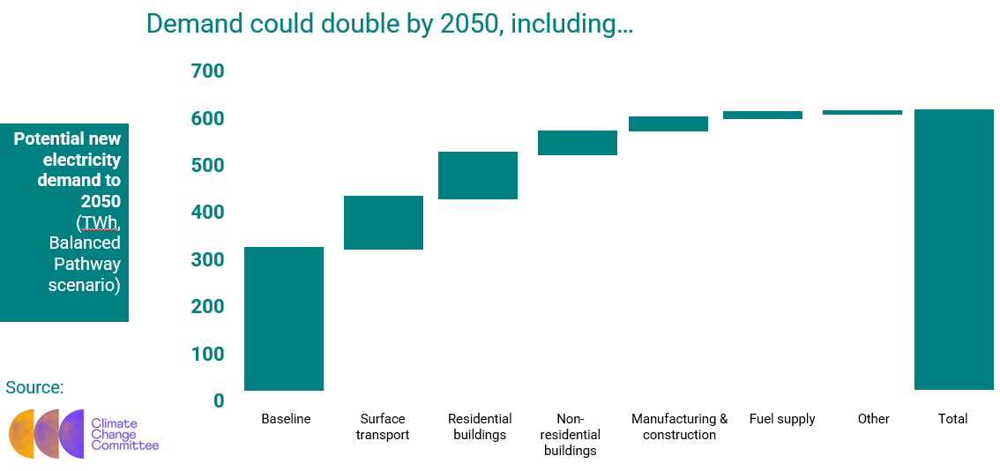
Fig 4. CCC’s forecast of electricity demand growth
  - This significant expansion in new demand sources means that grid connection requests are not just being driven by new generation assets, but also by new demand assets like EV chargers and heat pumps.

  - This demand growth in turn means more that supply is needed – meaning that the grid must accommodate both the additional demand and the requisite generation. Currently around 60% of electricity in the UK is from low-carbon sources including nuclear, and the UK will need to not only decarbonise that residual 40% but also ensure sufficient generation capacity to meet anticipated future demand. Total generation capacity will thereby need to grow from ~100GW today to ~200GW by 2035, mostly from renewable sources (growing from ~40GW today to ~150GW).
Flexibility
  - Flexibility is the ability to shift the time and location of electricity generation and consumption to help balance supply and demand. As such, flexible assets like energy storage as well as demand response measures (where customers are incentivised to shift the energy use to different times) can adapt to help with balancing and so that capacity is used more efficiently. Flexibility will become a much bigger part of the future system, in part as it can enable more efficient use of capacity and can thereby help to delay or avoid costly grid upgrades.

  - Owing to the intermittency of renewables, nationally they will be complemented with both supply-side flexibility, firm generation and storage. National Grid ESO already runs several flexibility markets, but these mostly contract demand-responsive gas plants presently. There is potential however for cheaper low-carbon assets to play a larger role, as well as for more demand-side response measures (where customers are paid to modify their electricity use). To an extent this presently owes to the relative ease (and lower risk) of rapidly modifying a small number of gas plants, rather than engaging with many smaller, decentralised assets – but network operators and the ESO are looking to significantly expand the role of other sources of flexibility.

  - Doing so could be helpful in four respects: as a more cost-effective means of mitigating the need for upgrades and ensuring more efficient use of capacity; to enable quicker and cheaper connections; as an economic opportunity for the deployment of flexibility assets and for flexibility service providers; and as a means for households and businesses to cut energy bills.
Combined impact
  - The overall upshot of decentralisation, demand growth and greater flexibility is that the system is shifting from a system of passive consumers served by a one-way flow of electricity from a few centralised generators, and towards a two-way system comprising millions of interacting and flexible generation, storage and demand assets and active consumer participation. This is in turn driving a significant increase in requests for connections, with the grid increasingly ‘constrained’ as its capacity struggles to keep pace. It also increasingly means that more balancing is required at the local and not just the national level, with DNOs thereby starting to play more of a role in balancing (and, thereby, in the commissioning of flexibility measures).

How are constraints managed?
  - Network operators have a responsibility to ensure capacity and to facilitate cost-effective reinforcement. That may be through upgrades to expand or install new substations, overhead lines or underground cables. In general, the higher up the grid you go, the more expensive and time-consuming reinforcement works are.

  - Reactive reinforcement may be required due to either incrementally greater demand from existing connected customers, or by their being ‘triggered’ by a new connection request. Requested new connections need to connect to either a modified or new line; and they may (but not always) require an upgrade through reinforcements. Network operators provide projects with estimates of the costs and options. Areas of constrained capacity can be expensive to connect to if they need reinforcements.

  - Reinforcements that are not triggered by a new connection request are assessed and approved by Ofgem, as the cost is recovered from all customers. Ofgem also now allows for proactive reinforcement of the network in anticipation of forecast future demand if evidenced – as explained further below. This shift to more anticipatory investment is still relatively new, and reinforcement works have traditionally been mostly reactive.

  - Permitting more investment ahead of need would help cut connection times and costs, but Ofgem also balances the risk of less efficient use of grid capacity, the costs for electricity bills, and the risk of stranded assets.

  - Customers partly bear the costs for upgrades in two possible ways:
- Distribution Use of System (DUoS) and Transmission Network Use of System (TNUoS) charges are ongoing charges paid by all network users for ongoing operations and maintenance costs – including reinforcements needed for incremental increases. They are paid indirectly via electricity suppliers, and form the ‘network costs’ element of a customer bill (around 25% of the total). Each DNO sets their own DUoS charges within regulatory limits.
- Connection Charges are one-off costs invoiced to customers seeking new connections specifically which recover part of the costs of requested new connections – including the connection assets (like cabling or metering) and a proportion of any reinforcement costs. These costs are outlined in Connection Agreements and some aspects of the agreements are negotiable. Significantly, from April 2023, connection charges for reinforcement were removed for demand customers and reduced for generation customers.

  - The amount that network operators can charge bill payers to recover the costs of grid upgrades is determined by Ofgem, which balances customer protections with the need for grid investment. The total amount that consumers can be charged is determined through the ‘price controls process’ using the ‘RIIO framework’ (see below) – which effectively sets a price cap for 5 year periods. It sets a framework to apportion risks and costs between network operators, connecting customers and bill payers.

  - Given the system changes already noted, there is a need for unprecedented build of new network infrastructure. However, managing capacity constraints won’t just rely on expansions to capacity. Investment in further capacity is only one means to address constraints, and innovative alternatives that don’t necessarily grow electricity bills are encouraged by Ofgem.,

  - In particular, flexibility is vitally important in order to make most efficient use of capacity. Flexibility measures like energy storage and demand-side response schemes (such as financial rewards to cut electricity use in peak periods) will help to mitigate (defer or avoid) the need for more expensive infrastructure upgrades. As such, it is an important cost-effective alternative, and can cut the costs and time it takes for new connections. Accordingly, network operators have committed to a ‘flexibility first’ approach where they prioritise flexibility measures above reinforcement. Understanding the role of and value of investment in flexibility will be as important as considering grid upgrades.

  - Additionally, flexibility will provide opportunities for consumers to play a more active role in how the system is managed by, for example, getting paid to adapt their demand, supply power which they generate themselves, or to store electricity if they have the facility to do so.

How are constraints forecast?
  - As noted, network operators have a responsibility to ensure capacity for future forecast demand. Doing so requires modelling to forecast future supply and demand in order to anticipate the location, timing and scale of constraints within the network.

  - The future shape of constraints on the network is likely to be determined by major factors which effect generation and demand, like the location of new development, the extent of new renewable generation, the deployment of EV chargers and heat pumps, or the extent of improvements in building energy efficiency.

  - At the national scale, National Grid ESO prepares ‘Future Energy Scenarios’ annually, which outline four potential pathways to 2050 for the transmission network. Each scenario essentially describes a different way to decarbonise the grid – and so make different assumptions over key variables like the extent of investment, household efficiency retrofitting, EV take-up, and the relative role of hydrogen boilers and heat pumps.

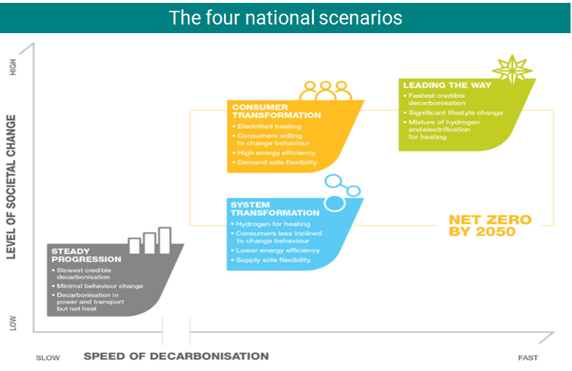
Fig 5. National Grid’s pathways to 2050, which are the basis of forecasting
  - The Consumer Transformation scenario focuses more on changing how we use energy. System Transformation focuses more on changing how energy is generated and supplied. Leading the Way describes the fastest feasible trajectory that is a mix of those two, involving high consumer engagement, innovative tech and high investment to get to net zero before 2050. Steady Progression falls short. Each scenario has different corresponding implications for expected peak demand.
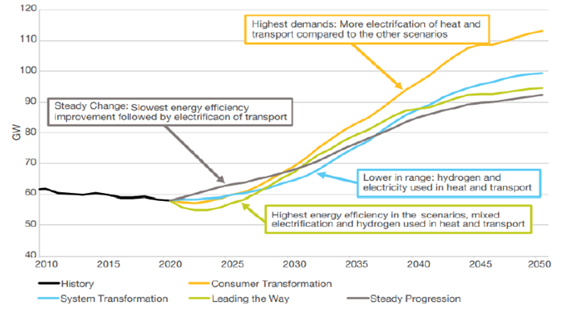
Fig 6. Peak demand implications of those scenarios
  - The scenarios in turn have encode assumptions about a range of factors regarding the pace of deployment for low carbon technologies like heat pumps and EVs, reflecting the expected impact of current government policy. Additionally, whilst the transition will significantly increase electricity demand, that will need to be mitigated by means such as energy efficiency improvements. As such, improving the energy efficiency of buildings should be understood as an important means of managing grid constraints, as the less efficient our buildings are, the higher their energy demand and the more pressure they place on the grid. The scenarios thereby also encode assumptions about the pace of improvement to building energy efficiency.

  - The different scenarios also model the variable contribution of different fuel types. Figure 7 illustrates how overall energy demand is projected to be cut under all scenarios compared to today, but that electricity makes up a much bigger proportion of overall energy use (almost doubling in the Consumer Transformation scenario).

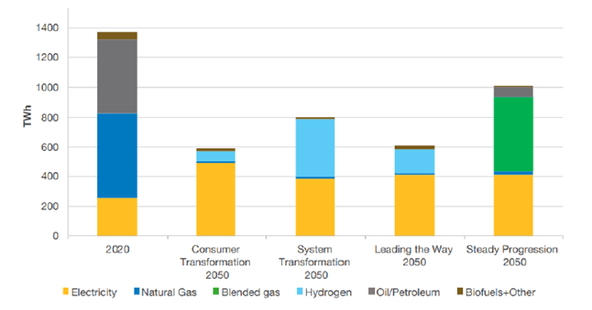
Fig 7. Differences in types of fuel demand in the scenarios
  - The Climate Change Committee generate the statutory Carbon Budgets to get to net zero, and all but one of the Future Energy Scenarios stay within budget. One – Steady Progression – isn’t compliant with the statutory carbon budget nor the Paris Agreement.
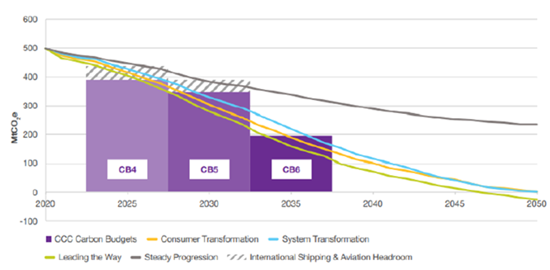
Fig 8. Implications of the scenario for staying within the UK carbon budgets
  - The foregoing analysis focuses on the transmission level, but DNOs also undertake annual forecasting to 2050 through ‘Distribution Future Energy Scenarios’ (DFES) for the local grid. This forecasting enables the DNOs to plan for reinforcement or through flexibility measures, and provides the evidence base for investment in either. Both SSEN and National Grid work with Regen to produce these.

  - Regen’s DFES scenario modelling uses the same framework, definitions and scenarios as the FES, but uses more local assumptions and more locally detailed forecasts. Model generation, demand and storage in order to anticipate future load scenarios and the location and timing of demand locally. This enables them to forecast where and when constraints are likely to emerge.

  - The modelling considers the baseline of operational or connected projects now, and what’s in the pipeline. It then models to the medium and long-term and distributes these geographically.

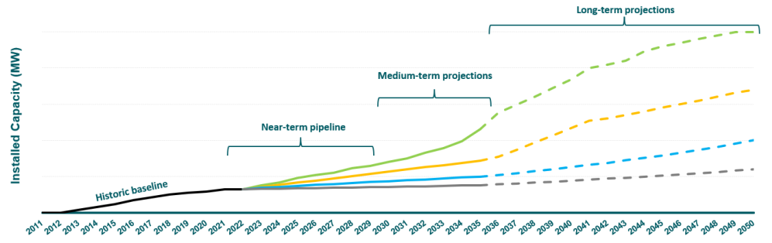
Fig 9. Considerations informing local forecasting
  - The projections are informed by an evidence base that consider technological and socio-economic factors, consumer behaviour assumptions, local authority strategies and plans for things like local housing development targets, and national policy (like the Future Buildings Standards) amongst other things. There are of course uncertainties on things like policy, tech, and consumer behaviour – and effort is made to factor these into the scenarios.

  - These DFES are also informed by engagement with local stakeholders, and DNOs hold multiple consultation and engagement events and actively seek information from local authorities – particularly on development and net zero plans. Many Dorset Council officers input into these forecasting processes.

How does network investment work?
  - The FES and DFES forecasts are the basis of the strategic investment process, and they inform a suite of documents including a Network Development Plan, Network Options Assessment, and then finally a business case for future investment. These determine when and where grid infrastructure needs upgrading. They require high confidence on the necessity of works, provided through robust evidence on trends (like on the pace of EV uptake) or local ambitions (e.g. commitment to develop a particular renewables project). The greater the confidence that can be given about local trends or projects, the stronger the Business Plan can be to evidence investment need.

  - The options assessments include holistic consideration of reinforcement alongside flexibility and demand-side response measures as well as other innovative solutions.

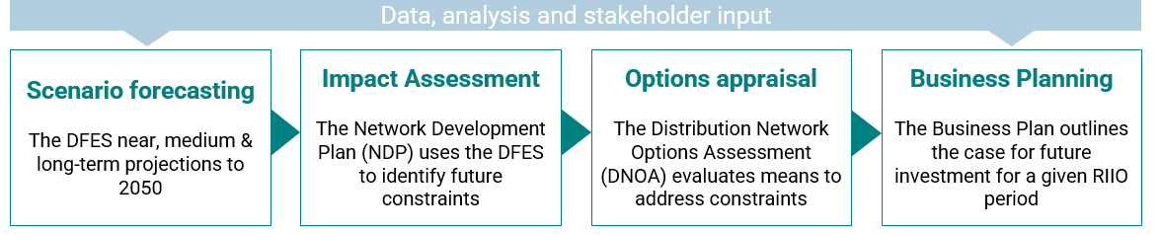
Fig 10. Steps informing investment planning

  - As noted above, the networks are subject to ‘price controls’ by Ofgem, which is regulated under the ‘RIIO’ framework, and which caps the revenue that can be collected from customers in line with its consumer protection duty. Network operators produce business plans outlining their planned expenditure, which Ofgem reviews and approves to set a cap on expenditure (and thereby, the amount that can be recouped from bill payers).

  - The Business Plans are produced for 5-year ‘regulatory control periods’ in which investment is planned. These are submitted to Ofgem for approval and determine the level of investment that can be undertaken in that period – and for which they are given penalties and incentives to stay within, including for ‘load-related expenditure’ (i.e. the costs of expanding grid capacity).

  - The current price control period for distribution networks is called RIIO-ED2 and runs from 2023-2028. The current price control period for transmission networks is called RIIO-T2 and runs from 2021-2026.

What are the constraints locally?
  - There are three Grid Supply Points that supply the Dorset Council area, at Axminster, Chickerell and Mannington – and these in turn serve 13 local Bulk Supply Points and around 50 Primary Substations.
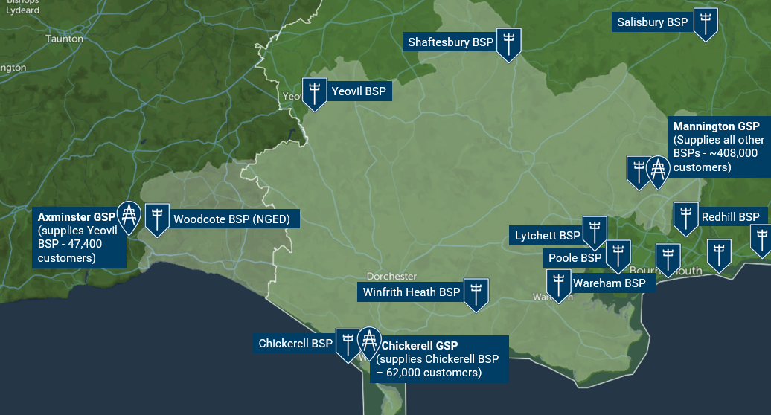
Fig 11. Dorset’s Grid and Bulk Supply Points

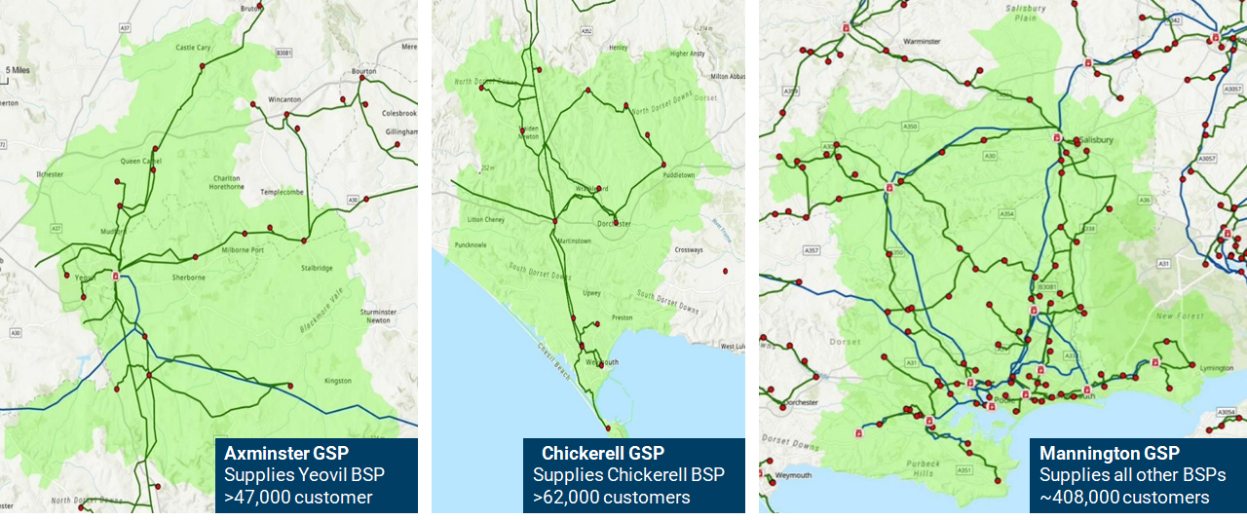
Fig 11. Dorset’s three GSP areas with primary substations

  - Both DNOs produce up-to-date and detailed interactive maps which show the constraint status, the level in the network where the constraint is, and planned reinforcement works and completion dates. (As that information is liable to be refreshed regularly, the live maps should be consulted rather than the indicative illustrations in figures 11 and 12.)

  - Detail on constraints and the current plans to address them are available in the following suite of documents:
  - Online heat maps (SSEN Network Capacity Map | NGED Network Capacity Map) which show where there’s currently headroom capacity, or where it’s limited or non-existent. These can help inform developers where connections are more or less likely to trigger reinforcements.
- Long-Term Development Statements are annual statements which give a rolling 0-5yr view, showing where is expected to reach capacity in the next 5 years. They’re published each November and updated each May.
- (Distribution) Future Energy Scenarios which are the annual, scenario-based, long-term projections to 2050 using four scenarios.
- Business Plans which are the investment proposals that have to be approved by Ofgem for each 5-year price control period.
- Network Development Plans incorporate all of those but give a longer-term 10yr plan to address constraints. But they only show intent as they’re subject to the Ofgem’s agreement of the underlying Business Plans; and they can be modified if future forecasting justifies such.

  - Most of Dorset’s network is already showing as constrained or partially constrained. This is inhibiting some project delivery and resulting in the delay, curtailment or cancellation of some projects due to prohibitive costs or delays impairing project viability. Consequently, it is impairing opportunities in areas like Bridport, Weymouth, Portland, Holton Heath industrial Estate, & North Dorset Business Park. According to the DFES, under a central scenario several local substations are likely to totally exceed current capacity by 2030 if not reinforced, and capacity would likely be exceeded at most substations by 2040.
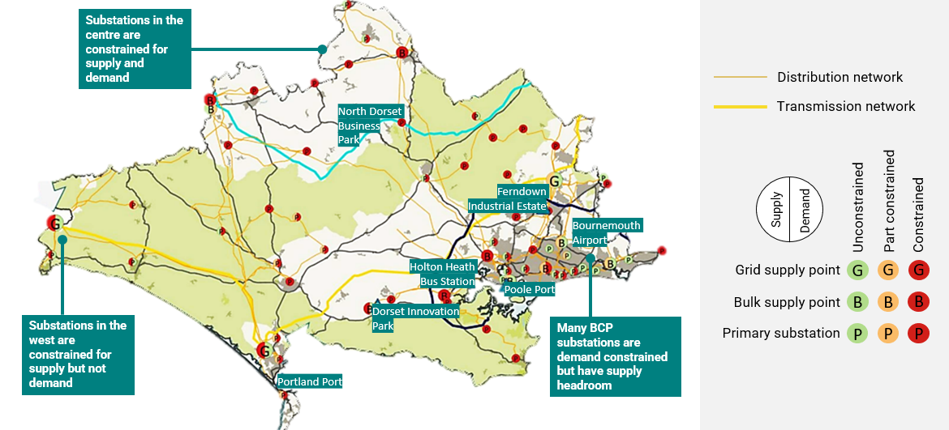
Fig 12. Local constraints currently (2021 analysis)
  - It should be emphasised that this information uses best available information on network condition, but further issues can emerge during specific projects. Network operators will undertake detailed feasibility analysis of particular assets on request for a small cost by customers seeking connections, and this can result in further issues being identified. Further delays to delivery can also emerge from issues such as landowner access permissions, consenting processes, or legal matters.

  - Addressing our network’s constraints will necessitate expansion of substation capacity and the creation of new substations alongside other reinforcements for lines and cables. Demand will also need to be mitigated through new builds standards, retrofit programmes to improve energy efficiency, and flexibility measures.

What are the primary challenges?
  - As noted above, the fundamental issue is one of constrained capacity and consequent delays and costs for connecting new assets. As well as acting as a drag on projects requiring connections and associated investments, it thereby increases the costs of the energy transition.

  - Throughout our sessions we heard from a wide range of local stakeholders who identified the contours of these challenges and their impacts – as well as recommending how the council might play a role in resolving them. They told us of many major and minor renewables, EV charger and building retrofit projects they had underway, many of which were running into capacity issues. Some of the key themes noted by stakeholders included:

Issues:
- Extreme delays to 2036 for connection times owing to transmission-level constraints.
- A very lengthy queue for connections, and its congestion with often speculative and unviable projects.
- More strategic projects often being stuck behind less strategic projects in the queue, owing to non-discrimination requirements in the process.
- Delays arising from non-infrastructural factors like wayleaves.
- Customer service issues for connecting customers, such as long waits for quotes or the inefficiency of having to manage non-standardised processes that vary across different network operators.
- Barriers to connecting due to inadequacies how the anticipated impacts of new connections are modelled overestimating risk, particularly for battery storage, and solar PV outside of summer peak periods.
- Requests for significant deposits (e.g. £200k) even for projects that have been given 10-12yr connection dates.
- Lack of upfront clarity about network infrastructure’s precise location of condition, with the risk that further significant challenges can emerge once detailed feasibility work for individual connections is undertaken.
- Limited awareness by connecting customers on the extent of competitive demand for individual connections, and thereby of the likelihood of attaining one without incurring significant costs – to inform earlier customer decision-making about siting and the worthiness of sinking resource into an application.

Impacts:
- Reinforcement costs and delays threatening the timeliness or viability of projects – including risks to renewable deployment, business expansion and development.,
- Significant project cost uncertainties owing to connection costs tending to increase substantially if requoted (sometimes by tens or hundreds of thousands).
- Delayed or deterred investment, particularly in renewable generation.
- Constraints to business growth potential or to the siting and relocation of high-energy using industries.
- Impediments to plant electrification to decarbonise high-energy industry.
- Limits on export rates for renewable generation impairing their income generation potential.
- Systemic incentives to install smaller capacity assets (under ‘connect and notify’ rules) in order to avoid the risk of connection delays.
- Missed opportunities to install heat pumps when boilers need replacing due to the risk of connection delays (during which period the building would lack heating or hot water), with the result that new gas boilers are instead locked in for the duration of their lifetime.
- Knock-on strategic economic risks, such as for investment in renewables, or to the tourism economy through impediments to EV charger provision or shore power/cruise electrification.
- Risks of exacerbating rural/urban disparities.

Solutions:
- Better evidencing the local need for network investment.
- Forging stronger strategic and collaborative relationships with network operators.
- Supporting better strategic planning of the network at a regional and local scale, to better fit local knowledge and ambition on net zero, development and economic growth.
- Lobbying on key constraints (e.g. Mannington GSP) to aim to expedite upgrades.
- Enabling wider use of constraint mitigation measures, including flexibility measures and energy storage, microgrids, alternative low carbon heat sources like geothermal, energy efficiency measures, and renewable colocation.
- Working cross-boundary and at a regional scale to make the case for investment.
- Better embedding the issue within local policy framework and decision-making, particularly planning.
- Exploring the opportunities for innovation projects and of Ofgem innovation funding.

  - The remainder of this section aims to unpick the causes underlying these issues further; and sketches the reforms that are emerging to address them. As it notes, there has been substantial reform announced during the course of this review in order to begin addressing many of these challenges. Further detail on the nature of the rapidly evolving policy and regulatory landscape is provided in the appendix.

  - A lack of strategic anticipatory investment
    - Until recently, grid development has only occurred piecemeal and reactively in response to demand (rather than in anticipation of it), and there has been a lack of strategic planning and coordination of energy generation infrastructure deployment with grid upgrades. This owed to the traditional regulatory framework lacking mechanisms to facilitate strategic investment ahead of need.

    - There has emerged, therefore, widespread acknowledgement of the need to facilitate significantly greater anticipatory investment, guided by strategic network planning. Government and Ofgem are consequently creating a framework for this. Initial steps towards this emerged through the Accelerated Strategic Transmission Investment (ASTI) framework which achieved this for offshore wind transmission; and more significantly through the introduction of the RIIO price controls framework.

    - Of central concern for the future is how well the design of the RIIO framework does at facilitating sufficient levels of strategic investment. Whilst there is strong consensus about the need for greater strategic grid investment – especially for transmission assets – the determination of the level investment is sensitive to two key issues: (i) uncertainties around the pace of deployment for assets like EV chargers and heat pumps, and (ii) increased costs for consumer bills, particularly if those arise from the installation of underutilised network assets.

    - Some stakeholders emphasise that the level of permitted investment with RIIO is insufficient, and that the costs incurred by customers of overinvesting is small whereas the consequences of underinvestment would be significant. Others, like Citizens Advice for example, have stated that RIIO-ED1 (2015-23) resulted in unnecessary costs for consumer bills due to overestimates of the pace of rollout for things like EVs and heat pumps., ,

    - Ofgem aimed to better manage the uncertainties involved in forecasting the rollout of low carbon tech within RIIO-ED2, by lowering the allowances and instead introducing mechanisms that will release further funding if the need arises (i.e. if the pace of EV or heat pump deployment triggers it).

    - Consequently, Ofgem’s final determinations for RIIO-ED2 (the current 2023-2028 period for distribution networks) doubled the amount permitted for investment compared to the previous period to £22.2bn. That was, however, £2.9bn lower than that sought by DNOs, with the component for reinforcement 17% lower than sought – but the uncertainty mechanisms should unlock contingent funding above that baseline if required. The cost to bill payers of RIIO-ED-2 (~£100/yr) was kept the same as for RIIO-ED1, with the growth in investment mostly deriving from operational efficiencies or cuts to network operator profits. In October Ofgem also released its framework for RIIO-

    - Given the strategic importance to Dorset of both the levels of grid investment and the impacts on consumer bills, participants emphasised to us that Dorset Council has a strategic interest in ensuring we do all we can to support networks operators where possible to evidence the case for investment in future RIIO price control periods and within the opportunities provided by the RIIO-ED-2 uncertainty mechanisms. This will in part concern strengthening engagement and data sharing with them, but may further involve work on strategic energy planning, as noted below. The council may have a related interest in engaging in future Ofgem consultations on the design of future RIIO price control periods, including the currently open consultation on RIIO-3 for transmission.

  - A lack of strategic network planning
    - The lack of a mechanism for anticipatory investment in part owed to the lack of strategic network planning which could inform decisions on what to build, where and when. Long-term network planning will be crucial to alleviate constraints, and to inform consenting and investment decisions that will support the deployment of grid infrastructure, renewable generation and electricity storage assets.

    - The introduction of the RIIO framework has begun addressing this through the role of Business Plans which, as mentioned, strongly rely on strategic forecasts for how generation and demand is projected to evolve. Network operators will only invest if they can recover the costs, so they must robustly evidence clear need to Ofgem through these plans.

    - There is, however, an opportunity to significantly strengthen strategic network planning, and thereby the case than can be made to Ofgem to evidence the need for investment. This would be valuable both for future price control periods, but also could help unlock within-period opportunities arising from the new uncertainty mechanisms mentioned above.

    - Nationally several key reforms are emerging to strengthen strategic network planning, most centrally:
- The forthcoming creation in 2024 of an independent, impartial and publicly owned ‘Future System Operator’ (FSO), to assess, advice and strategically plan the whole cross-vector energy system across electricity and gas. It will build on the ESO role by managing the system in real time as well as undertaking strategic planning.
- The creation of a Strategic Spatial Energy Plan (SSEP) and then Central Strategic Network Plans (CSNP) – comprehensive transmission network plans for electricity and gas, to be developed by the FSO that will effectively determine a pipeline of transmission infrastructure projects.
- The forthcoming development of Regional Energy Plans by the recently announced Regional Energy System Planners, which Local Authorities will have a role in. The plans will consider whole energy system needs (electricity, gas, heat networks, hydrogen etc.) at a regional scale.

    - These national- and regional-scale strategic plans will mark a significant step forward to guide investment, and the regional-scale plans in particular present a good opportunity for the council to input and better evidence the case for local investment.

    - However, there remains a risk that this suite of plans will still lack granular, local-scale insight on need. This can in part be addressed through enhancing engagement and data-sharing with network operators to inform their forecasting work. There are already strong examples of the council sharing data on aspects such as housing development targets, and it may be considered whether there are opportunities to enhance this engagement further in conversation with the network operators.

    - The ultimate need is to provide a robust basis for network operators to evidence to Ofgem where, when and how a local area requires investment. Network operators require a high level of certainty and specificity to justify their case to Ofgem. Working together to provide that will therefore be key.

    - In part for that reason, some local authorities have created – or are in the process of creating – Local Area Energy Plans LAEPs. These are medium/long-term, strategic, granular (i.e. postcode-level), cross-vector plans for the local energy system in a specific area – bringing together national and local datasets with local stakeholder engagement insight to identify decarbonisation pathways for a locality. As whole-system plans, they consider electricity, heat and transport as well as how energy is generated, stored, transported and used.

    - LAEPs are collaborative plans co-developed through extensive engagement with local authorities and other public sector bodies; energy generators, network operators, and suppliers; local renewable developers and low carbon tech deployers; developers; industry; and consumers and communities. Local authorities are well placed to convene these stakeholders alongside other expert input from network operators to develop a plan – and to establish governance for its delivery.

    - A well-evidenced plan with strong local buy-in can help steer the design of local projects and investments for low carbon tech deployment, and to clarify and justify the case for targeted network investment. Accordingly, the ENA and network operators are very supportive of their creation.

    - To be impactful, LAEPs must consider and inform network operator investment planning, be dynamic or iterative in response to the evolution of the energy system, and be realistic about the pace of delivery. There are multiple methodologies for developing LAEPs – including that from Energy System Catapult and other more bespoke approaches. But broadly, they encompass stakeholder engagement, baseline data analysis, scenario modelling, and the identification of a preferred decarbonisation pathway.

    - Around 66 councils have now created a LAEP or are in the process of doing so. Examples of LAEPs already developed include those of Greater Manchester, Bristol, Peterborough (funded by Innovate UK’s Prospering for the Energy Revolution programme), and North Yorkshire & York (funded by the UK Community Renewable Fund and City of York). Other LAEPs are currently in development, such as in Cornwall (funded by its devolution deal), Somerset and in BCP. It should be noted that these involve a wide variety of methodologies, granularities, and thereby costs.

    - The is currently no formal requirement to create – nor a statutory role for – LAEPs in England, akin to Local Plans or Local Transport Plans. Nor, consequently, is there a prescribed, standardised method. Government’s latest statement on LAEPs appears to have been its March 2023 response to the Independent Review of Net Zero, whereby it stated that it “has work underway to consider the role of Local Area Energy Planning (LAEP) in delivering net zero and in supporting efficient network planning. This includes engaging with Ofgem as part of its ongoing governance review into local energy institutions…”. However, Ofgem’s decision on that review merely stated that “our proposal does not prescribe the use of the LAEP methodology by LAs and this is an area of consideration for government.” Nevertheless, participants in the inquiry stressed that a lack of duty to create one does not mean that we should not do so.

    - Officers informed the inquiry that they believe there is value in having a stack of nesting national, regional and local energy plans – and that local energy planning would give helpful granularity. But they noted that they have been cautious about how to approach developing a LAEP owing to the costs involved, the lack of a clear formal role and the expectation that such may have been clarified during the recent reform announcements. Accordingly, the Sustainability Team signed up to become one of five pilots to trial a new geospatial energy planning tool developed by SSEN as a first step. It is the first geospatial energy planning tool designed specifically to support local authority decision-making – complete with extensive spatial datasets, forecasts and modelling on matters from constraints to low carbon tech.

    - Conversation are also underway with the SW Net Zero Energy Hub and local authorities to identify potential opportunities for more cost-effective engagement approaches. Owing to the likely staff resource required to progress such, and to examine these issues further, an energy officer is soon to be recruited to the sustainability team.

    - Given the importance of well-informed strategic planning to inform future investment decisions, participants emphasised that Dorset Council has a clear opportunity to strengthen data-sharing with network operators to inform their business plans; to actively prepare to play a strong role in the emerging system for developing regional plans; to further examine the most cost-effective means to develop a local area energy plan; and to better engage network operators in the creation of our own strategic plans.

  - Inadequate connection queue processes
  - The queue for connecting to the grid has grown considerably over recent years to almost 400GW worth projects. Connection date offers are 5yrs later than the requested date on average, whilst 40% of projects are offered dates of 2030 or beyond (with some as late as 2037). This impairs the allocation of capacity and decision-making on network upgrades, it can drive up costs, and it disincentivises investment in new generation or storage infrastructure.

    - Much of the problem lies with the transmission network, but the impacts aren’t confined there – as where projects connecting to the distribution network might impact the transmission level, approval must be given by National Grid ESO. This can result in distribution-level projects having to join the transmission queue.

    - Moreover, the delays have in turn given rise to a practice of ‘connection banking’, where speculative ‘zombie’ projects are submitted solely to secure a place in the queue even if not viable. To illustrate: the amount of low carbon generation capacity within the queue is currently around 3x that needed to decarbonise – but National Grid ESO estimates a very high attrition rate with only 30-40% of those projects likely to be developed with the rest mostly speculative.

    - There are several issues with the traditional process:
- As per its licence condition, the ESO doesn’t discriminate on factors like a project’s development status or viability (i.e. its likelihood of connecting).
- There is a low threshold for proving ability to deliver in order to enter the queue.
- Contracts impose limited obligations for developers to progress on time.
- Developers can delay termination by delaying their completion date through a modification application.

    - A significant part of the blame for this is widely agreed to inhere in the ‘first come, first served’ queuing policy which currently results in slow or stalled projects blocking the way for more viable projects. Whilst progression milestones have to be hit for projects connecting to the distribution network since 2017, there has been no such requirement for transmission projects. It is therefore widely recognised that reforming queue processes is essential to enable the deprioritisation or removal of speculative and slow projects, so that more viable projects can advance more quickly.

    - Two key reform efforts have begun to address this problem:
- Industry action: In mid-2023 industry set out two key action plans – the ESO’s 5-point plan and the ENA’s 3-point plan – which amongst other issues will help to reduce queue times through means like a queue amnesty, better impact modelling, and means to terminate stalled projects.
- Government/Ofgem action: During the course of this inquiry government released a Connections Action Plan to improve queue access and management processes – with an ambition to cut connection dates to be no longer than 6 months after the sought connection date, compared to the current average of 5 years. It sets out six areas of action, including raising entry requirements to deter speculation, new powers to remove stalled projects, and dropping the first-come-first-served policy through triaging.. The first terminations from the queue are expected in early 2024.

    - These reforms are only just being implemented so it will take time to see if they have their intended effects, but if effective could go some significant way to addressing some of the challenges we heard from local participants. There is scope for Dorset Council to examine whether we could work better with network operators to support efforts to implement these actions in order to rapidly free up local capacity. It is also apparent that the queue reforms don’t address the issue raised locally (noted in 9.2) that certain strategic stakeholders aren’t prioritised in the queue due to non-discrimination rules, so this may be an issue to lobby on for further reform.

  - Poor coordination and sub-national governance
    - Some delays and inefficiencies derive from inconsistency in planning and delivery across institutions and across vectors (gas and electric), resulting in further inefficiencies and delays. This means that there is a patchwork of plans which make inconsistent forecasts, as well as little accountability and inconsistent engagement with local authorities.

    - Whilst there are facilities like sub-national transport bodies that provide statutory transport governance, there is no equivalent for the energy system which enables strategic coordination and democratic input. This is a barrier to enabling joined-up strategic planning and investment.

    - In December Ofgem determined new arrangements for sub-national governance following consultation. It has decided to introduce Regional Energy Strategic Planners (RESPs).
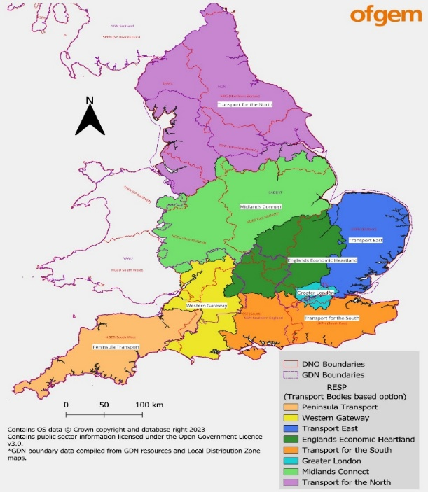
    - RESPs will be a new form of regional governance with responsibility for developing and delivering regional energy plans. These will reflect place-based insights and priorities and coordinate local engagement. They will convene local authorities with networks and other key stakeholders – and will provide support local authorities with advice, data and tools.

    - 10-13 RESPs will be established nationally, following the boundaries of sub-national transport bodies. For Dorset, this would correspond to the footprint of our Western Gateway sub-national transport body (the yellow region in the map).

    - Designs for their role, operations and implementation will be developed in 2024, with trials, further engagement and consultation towards their establishment in late 2025 or early 2026.

    - Participants emphasised to us that there is a strong opportunity to play a strong role in Regional Energy System Planners; to reflect on how we can most effectively give voice to local communities and stakeholders through those boards; and to proactively engage to influence their design and implementation throughout 2024. Several participants emphasised the significance of the opportunity they provide to strengthen relationships with network operators and unlock more strategic energy planning. It is also likely that Dorset may have a strategic interest in the South West (Peninsula) RESP, so might also seek to engage Ofgem to question the approach to cross-RESP coordination – and whether we might attain participation in, or observer status for, that RESP once it is established.

  - Poor infrastructure build times
    - Grid infrastructure development which qualifies as ‘Nationally Significant Infrastructure Projects’ (NSIP) has been subject to consenting delays that have played a role in delaying infrastructure build times – and thereby aggravated the wait times for consents dependent upon them. These challenges have been highlighted by both the National Infrastructure Commission and government’s Electricity Networks Commissioner.

    - The challenges identified have included outdated National Policy Statements, consenting delays reaching an average of 4yrs, inadequate engagement (including insufficient local authority capacity to engage with the process), and inconsistent and ineffectual approaches to community benefits for communities which host transmission infrastructure.

    - Government has consequently pursued reforms to the NSIP regime more broadly, to speed up consents through streamlined processes, enhancing community engagement, and improving resourcing. Most of the reforms are expected to come into effect by April 2024.

    - Additionally, in November government released an action plan for accelerating transmission infrastructure specifically – aiming to cut build times from 12-14yrs to 7yrs. It outlines commitments (as mentioned above) on strategic network planning, improving designs and standards, fast-track consenting and streamlined regulatory approvals, new guidance on compulsory purchase and land access rights, and a more strategic approach to supply chain and skills – including a Green Jobs Plan to be published in 2024. It also was accompanied by further detail on the arrangements for community benefits for communities hosting transmission infrastructure, and a national comms campaign to better inform communities on the need, opportunities and benefits of new grid infrastructure.

    - The constraints of a location or area are a consideration in local planning decision making, as an aspect of sustainable development. Assessment of the potential for strategic energy infrastructure (such as wind and solar energy development) will be undertaken in the preparation of the new Local Plan, considering factors such as technical potential for development, and landscape sensitivity. The Council will also seek the views of energy operators when preparing the Local Plan, with a view to understanding how grid capacity may affect its approach to development. The NPPF was revised and published on 19 December 2023 in response to the Levelling-Up and Regeneration Act coming into force, but this was too late for this inquiry to examine whether it may have implications for grid infrastructure specifically.

    - Both local authorities and communities are important consultees in the NSIP process. Accordingly, there may be opportunities to consider whether there are opportunities to better engage in any future grid NSIP consenting processes, whether our communities might gain from the new community benefits regime, and whether local policy and decision-making could learn from the NSIP reforms’ integration of strategic network planning. Additionally, we should maintain awareness of how elements of the transmission action plan – including the national comms campaign and green skills plan – develop and could be utilised at the local scale.

  - Nascent flexibility markets
    - As we have noted previously, upgrading grid infrastructure is only one half of the job of efficiently managing grid capacity. Just as important is enabling flexibility services. Smart and flexible systems will cut the need for new grid infrastructure, particularly regional flexibility markets. It is estimated that smart and flexibility tech (such as storage and smart charging) could save £10bn/yr by 2050 by reducing generation and grid needs.

    - Both the ESO (for transmission) and DNOs (for distribution) procure flexibility services and are considering how to facilitate more low carbon tech – including through the ENA’s Open Network Programme. However, these markets are still nascent for low carbon assets, with barriers around inconsistent rules and processes, poor data and digitisation, and ineffective market signals. Mainstreaming demand-side response measures will also be dependent upon the wider installation of smart meters, and by the forthcoming 2025 rollout of ‘market-wide half hourly settlements’ that will enable more time-of-use tariffs for consumers.

    - As regards the ESO, it first established a winter Demand Flexibility Service in 2022/23 where consumers were given financial incentives to cut usage at peak times, and which saw over a million participants and a 2GWh cut in demand. It also operates a Local Constraint Market at the England/Scotland border, where it auctions supply requirements to generation or storage asset owners like grid-scale batteries and EV charger aggregations. The ESO is now undertaking a review of its Demand Flexibility Service following its success, whilst Ofgem aims to make demand flexibility universal and automatic in the future to simplify customer participation.

    - Importantly, DNOs are also playing a growing role in procuring flexibility services, and thereby the nurturing of regional flexibility markets – and there have been now been several local flexibility market trials nationally. This marks a shift in their functions to take on more operational roles in local balancing. Flexibility was better embedded within RIIO-ED2, with new funding mechanisms and incentives to encourage a Flexibility First approach. Ofgem also encouraged DNOs to submit business cases for network monitoring equipment rollout in RIIO-ED2, subsequently approving £167.54m for this. This is enabling better digitisation and data necessary to unlock flexibility.

    - Importantly, Ofgem has also now clarified that it will create a new flexibility market facilitator to establish common rules, processes and standards for flexibility (ESO and DSO) markets and monitor their implementation, to improve the procurement of flexibility services. This is due to launch in 2025/26.

  - The future of flexibility markets is also importantly tied to future reforms to the wholesale electricity market, which are being reformed through government’s Review of Electricity Market Arrangements that launched in 2022. Of central interest is the consideration of whether to introduce locational pricing rather than having uniform national wholesale electricity prices, in order to incentivise flexibility assets like energy storage (as well as electricity generators and major sources of demand) to locate in particular places. If implemented this would allow wholesale prices to vary by location based on factors like local generation capacity, network constraints and demand – which could potentially incentivise flexible assets to deploy at more constrained locations. This is an area of ongoing review.

  - For smaller, decentralized consumers, intermediaries called ‘aggregators’ will also likely be needed to combine flexibility offers into saleable products for network operators. Whilst aggregation is common nationally, they’re not in local markets – but there may be opportunity for local businesses, community energy groups, or entities like housing associations to play a role in providing aggregation services as these markets develop.

  - There is an opportunity to better consider the nurturing of local flexibility markets and technologies to help mitigate grid capacity constraints, and to ensure that local households and businesses can benefit from the opportunities they provide. Dorset Council should maintain a watching brief on the evolution of the Demand Flexiblity Service, and engage our DNOs on opportunities to better nurture or trial schemes – including examining the potential role for local aggregators. Where opportunities arise we might also engage through future consultations on the design of the wholesale electricity markets as regards locational pricing.

Implications and recommendations
  - Dorset Council is and will continue to play a central role in the delivery of net zero locally – including through the leadership, policy frameworks, planning and investment required to support the deployment of low carbon technologies.

  - Alongside our role as a Local Planning Authority and Local Transport Authority, this means that we have a critical strategic interest in the future evolution of the energy system. Yet, unlike with transport and development – systems which are critically dependent upon the energy system – we currently play a much more peripheral role in strategically planning the local energy system.

  - Energy infrastructure needs to be seen through the same lens as other strategic infrastructure, with investment better aligned to local knowledge, ambition and decision-making. Our ambitions for net zero, development and economic growth will therefore require us to play a much more central role in local energy planning in the future – and strengthening our collaboration with energy networks will be essential for this. In so doing, we will be able to both better facilitate network investment aligned to our strategic ambitions, and maintain more efficient and collaborative operational relationships with network operators to smooth delivery.

  - Network operators explicitly recognise the importance of local energy planning and the importance of closer collaboration with local authorities. Accordingly the ENA and individual network operators are developing new processes, tools and roles specifically to strengthen such collaboration.

  - There is clear intent from network operators to further strengthen relationships with local authorities so that we can better collaborate, innovate, and develop capacity and capability. This means that we can reasonably expect further work to emerge over the coming years that will build on aforementioned data and planning tools through additional improvements on data sharing, visualisation, training and guidance, and processes. Our relationships will no doubt evolve as we reflect on our ways of working and develop new forms of good practice. Our trialling of SSEN’s LENZA tool is a strong demonstrator of the willingness and opportunity for closer collaboration.

  - It is essential that we strengthen our relationships with network operators. Whilst we already provide some data to inform their forecasting, and whilst there are good operational links with projects like our public EV charger programme – there is also much opportunity to strengthen our links in other areas. In particular, we must establish better two-way flows of information with network operators through regular, iterative, long-term engagement. Stronger, ongoing relationships with network operators are needed in each of the following respects:

- Strategic: Co-developing policy or strategies in well-established areas (e.g. planning, transport, housing, economic growth, net zero); strengthening our input into their forecasting work; developing new strategic local or regional energy plans; providing regular opportunity for strategic conversations about barriers or opportunities; and collaborating to co-develop innovation projects to unlock innovation funding through Ofgem’s Strategic Innovation Fund and UKRI.

- Operational: The planning and delivery of low carbon technology deployment projects (e.g. EV chargers, building retrofit) and development – including on barriers to approvals or consents; and strengthening support for vulnerable residents (e.g. on access to flexibility opportunities etc.).

This review therefore makes the following recommendations:

- Establish regular quarterly strategic meetings with network operators, to address strategic challenges and identify areas for collaboration or innovation. This should clarify single points of contact to coordinate meetings, facilitate data sharing, seeking or provide feedback on our respective plans, and identifying joint skills or comms opportunities. This may include brokering or facilitating strategic meetings between network operators and key local stakeholder groups like developers.

- Seize the opportunity of Regional Energy System Planners by proactively engaging now to influence their design and implementation, and by reflecting on how we can most effectively give voice to local stakeholders. Also seek clarity from Ofgem on our potential participation in the SW (Peninsula) RESP.

- Strengthen the evidence on local investment need to supporting network operators’ case for investment, by continuing to pursue a cost-effective route to Local Area Energy Planning – building on the strong opportunities of the LENZA trial and by co-developing an approach to engagement where possible.

- Ensure that grid constraints and constraint mitigation measures are embedded in our strategies, policy and decision-making, by better utilising emerging data and tools to inform our strategies/plans, decision-making, and delivery programme design – in particular, to engage network operators on our emerging plans and using the LENZA tool to inform discussions. This should also consider any wider but linked socio-economic risks or opportunities, such as from flexibility markets.

- Explore the opportunities of Ofgem’s Strategic Innovation Fund and our devolution asks to actively develop, trial and deliver new processes, tools and approaches with network operators – particularly for flexibility.

- Lobby our MPs, government, Ofgem and network operators on key grid issues such as expediting critical transmission infrastructure upgrades, queue prioritisation, and customer service improvements.

Appendix: 1: National policy and regulatory reform

As noted above, the above challenges are very much recognised by Government, Ofgem and industry – and they have therefore prompted a programme of significant but complex policy and regulatory reform. This appendix outlines chronologically the major elements particular to the grid from the last couple of years. As the dates indicate, this reform is very recent and still emerging, and so is still being implemented and embedded – but there appears to be clear enthusiasm from Government, the regulator and industry alike to resolve the systems challenges through these actions.
The following list outlines those policies of most direct relevance to the grid specifically. However, it should be emphasised that many broader policy and regulatory areas – from energy generation to building standards –will critically interact with the grid.
British Energy Security Strategy (April 2022): The BESS strategy sets the government’s overarching approach for a more affordable, clean, low carbon and secure energy system – with a central ambition to decarbonise the electricity system by 2035 (subject to supply security). As well as setting measures, objectives and milestones for energy generation, it set out key commitments on networks, storage and flexibility – guided by an expected doubling of demand by 2050. It emphasised planning ahead of need and flexibility as priorities, making the following key commitments:
- Establishing a Future Systems Operator.
- A strategic framework on how networks will deliver net zero.
- Appointing an Electricity Networks Commissioner as an advisor.
- A network blueprint through a Holistic Network Design (HND) and Centralised Strategic Network Plan (CSNP).
- Updating the National Policy Statements to recognise these in the planning system.
- A Strategy and Policy Statement for Ofgem that emphasises strategic investment.
- Speeding up connections to distribution networks.
- Cutting delivery of transmission infrastructure build times in half.
- Consulting on community benefits for network infrastructure.
- Developing policy to encourage investment in all forms of flexibility and widening use of flexible tariffs.
- Ensuring new homes have smart meters by 2024 (in advance of the Future Homes and Building Standards).
- Undertaking a Review of Electricity Market Arrangements for wholesale markets; and continuing the retail electricity market review.
Holistic Network Design & ASTI Framework (July 2022): The HND marked a step-change towards more strategic transmission network planning. It set out for the first time a strategic transmission network plan to facilitate offshore wind specifically. Subsequently, an Accelerating Strategic Transmission Investment (ASTI) Framework was launched to expedite projects within the HND under streamlined regulatory approval and funding processes. Whilst focused on needs for offshore wind specifically, these represent a major step towards strategic network planning and investment – particularly towards a more comprehensive Centralised Strategic Network Plan for the transmission network. Ofgem will review ASTI framework to assess its possible extension, which it will consult on in 2024.
Electricity Network Strategic Framework (August 2022): This outlines Government and Ofgem’s joint vision for the network, with more detail on policy and regulatory reform towards realising an efficient, smart, digitised, strategically planned, efficiently built and cost-effective grid. It was also accompanied by modelling of demand, generation, capacity, investment, and consumer & economic impacts. The framework notes the vision, progress and actions across a range of areas, including committing to future action on:
- Strategic network planning and the creation of the FSO
- Cutting constraints
- Enabling strategic investment
- Accelerating transmission infrastructure build-times
- Increasing competition and innovation
- Reviewing planning and consenting processes and land rights
- Connections charges and customer experience standards
- Facilitating flexibility and digitising the system
- Reviewing network charges
Powering Up Britain Energy Security Plan (March 2023): This constitutes sets out government’s latest plans for energy security and net zero, aiming to double domestic generation capacity and decarbonise power by 2035. Regarding the grid it aims to ensure investment at pace and scale – prioritising reform for accelerating infrastructure, anticipating need, and maximising flexibility. It includes commitments to:
- Develop an action plan to accelerate transmission infrastructure build time by at least 3 years and halve the duration of the end-to-end process (informed by the Electricity Network Commissioner’s recommendations).
- Develop an action plan on reform to accelerate distribution and transmission network connections.
- Consult on a Strategy and Policy Statement for energy, incorporating strategic network planning, anticipatory investment, and accelerating network build and connections.
- Improve the planning process by publishing a revised networks National Policy Statement for networks which refers to strategic network plans (for NSIP); and responding to the onshore wind and NPPF consultations.
- Respond to the call for evidence on land rights and consents reform, and support legislation for a new landowner dispute resolution mechanism for transmission infrastructure.
- Introduce guidance on appropriate levels and forms community benefits for network infrastructure, following its earlier consultation, to empower communities and ensure consistency.
- Consult on the FSO role, licenses and update on its implementation, towards its development of a full CSNP for the entire electricity network in 2025.
- Support moves to strengthen anticipatory investment through Ofgem’s review of future price control processes.
- Further develop a blueprint for offshore wind connections, conclude the Offshore Transmission Network Review & publish a Future Framework.
- Further consultation through the Review of Electricity Market Arrangements programme.
Industry Action Plans (March/April 2023): Two key industry action plans were released in mid-2023:
- At the transmission level, the ESO’s 5-point plan includes an amnesty for 45GW of projects (i.e. to terminate or reduce agreed capacity without penalty); amending its Construction Planning Assumptions to improve modelling of transmission-level impacts; improvinf modelling of storage asset impacts (e.g. by assuming that they don’t export at times of peak generation and import at times of peak demand); inserting progression milestones into connection agreements, to enable termination for stalled projects; and offering ‘non-firm’ connection options for storage assets (i.e. allow them to connect sooner by agreeing not to import or export under certain conditions).
- At the distribution level, the ENA’s 3-point plan includes measures to insert milestones into demand contracts and pre-2017 generation contracts and better enforcing them; improving interactions with the transmission network; and improving provisions and impact assessments for storage assets.
In the short-term, transmission capacity of 100GW should be freed by the ESO’s 5-point plan, improving connection dates for some customers by 2-10yrs (with new offers to be made from Q4 2023); and 39GW should be freed at the distribution level by the ENA’s 3-step plan. Further action and long-term reform needs to be undertaken, so this is an ongoing area of work. For instance, the ESO’s broader transmission connections reform project is considering wider reforms to create mechanisms that would enable progress-dependent accelarated connection dates as well as limited application windows for more strategic evaluation of applications in batches.
Draft Strategy and Policy Statement for energy policy (May 2023): The draft SPS for energy sets out government’s strategic priorities, sought outcomes, and roles and responsibilities. Ofgem and the FSO must undertake their functions with regard to it. It incorporates strategic network planning, anticipatory investment, and accelerating network build and connections. The consultation on the draft closed in August 2023, and government is now reviewing responses.
Energy Act 2023 (October 2023): The Act establishes a net zero duty for Ofgem alongside its consumer protection duty, which came into effect on 26 December 2023. It also establishes the legal basis for the creation of the Future System Operator; enables competitive tendering for the build, ownership and operation of the onshore grid; creates a new governance framework for energy codes to empower Ofgem to set the strategic direction for how the rules governing the system evolve to drive change; and contains measures on smart meters and appliances.
Reform of land rights and consents for network infrastructure (ongoing): Network operators often need to access private land to install, maintain and upgrade assets in order to facilitate new connections or undertake maintenance. Consequently, challenges arise from the hinderance or prevention of network infrastructure build owing to land rights and consents. The costs and timescales associated with negotiating access or purchase agreements are very unpredictable and can result in costs or delays for connecting projects. The relevant processes regard:
- Land access for overhead line installation (voluntary wayleave or easement or necessary wayleave access agreements).
- Land purchase for substation installation (freehold/leasehold purchase or CPO).
- Planning permission for overhead lines (s37 of the Electricity Act or a Development Consent Order under the Planning Act 2008).
- Planning permission for substations (Town & Country Planning Act, with Permitted development rights for those 29m³ or less).
- Planning permission for certain overhead lines (development consent order as NSIP)
In September 2022 government sought evidence on whether current processes need reform to ensure the efficient, cost-effective and fair delivery of network infrastructure. This recognises the need for an appropriate balance of network operators’ needs with protections for landowners and local stakeholders. Work is now underway on measures, including reforms to the CPO process following adoption of the Levelling Up and Regeneration Act. The response to the call for evidence is due in spring 2024, and a working group will be established.
NSIP Action Plan (Feb 2023): Some grid infrastructure development qualifies as ‘Nationally Significant Infrastructure Projects’ (NSIP), the planning regime for which is handled nationally. The National Infrastructure Commission has noted a likely increase in the volume of NSIPs broadly, and we might expect this particularly for the grid given the issues noted. This Action Plan sets out a programme of reform, broadly aiming to speed up consents through streamlined processes, better community engagement, and better resourcing., Most of the reforms expected to come into effect by April 2024. Both local authorities and communities are important consultees in the NSIP process, and reforms that may be of most local interest regarding the grid include:
- Strategic direction: The National Policy Statement (NPS) for electricity network infrastructure has been reviewed, setting out the strategic needs case to inform decision-making. Amongst other things, it now explicitly links decision-making to strategic spatial energy planning. It came into force in January 2024.
- Fast-tracking consents: Reform to the consenting process includes proposals for a fast-track route for eligible projects meeting quality standards, and aiming for a non-statutory 12-month target timescale from acceptance to decision.
- Resourcing engagement: Recognising time and resource barriers to engagement, government has proposed further innovation & capacity building (including a new round of the Innovation and Capacity Fund) and new guidance on forming agreements with applicants for recovery of engagement costs (given agreed service levels). For communities, it proposes better guidance on expectations for community engagement and introduction of an earlier milestone to examine its adequacy.
- Community benefits: Recognising the need for more consistency in the provision of benefits for communities hosting infrastructure, government has proposed to strengthen the community benefits regime. Detail on proposals for electricity transmission network infrastructure specifically was subsequently outlined in late 2023, as detailed below.
Community Benefits for transmission network infrastructure (November 2023): Following consultation in March 2023, government has proposed new guidance on the levels and form of benefits for communities hosting new transmission infrastructure – to ensure greater consistency and to empower communities in their discussions with developers. It has determined to adopt a bill discount for properties closest to infrastructure of up to £10k per property over 10 years, alongside wider community benefits of £200k/km for overhead lines, £40k/km for cables, and £200k per substation. It is now working on implementation and plans to publish voluntary guidance in 2024 – whilst exploring options for a mandatory approach in 2024.
The Transmission Acceleration Action Plan (November 2023): This action plan responds to the recommendations of the Electricity Network Commissioner. It aims to significantly cut end-to-end build time for transmission infrastructure from 12-14yrs to 7yrs. The programme of work is expected to cut delays, constraint costs, and could increase investment by £15bn over the decade. The effect for consumer bills is expected to be a net saving of £15-25/yr on average per household between 2024-35. The Action Plan will be governed by a new minister-chaired forum, aligned to that for the Connection Actions Plan. The plan contains measures including:
- Improving strategic spatial planning for the network through the creation of a Strategic Spatial Energy Plan (SSEP) to determine the optimal location of infrastructure, as the basis of short- and long-term Centralised Strategic Network Plans (CSNP). Work is now underway to develop an SSEP, with the first iteration focusing on power and hydrogen. The longer-term CSNP will thereby be produced every three years from 2026 and consider long-term investment to at least 2050; whilst the short-term CSNP will be produced annually with a 12yr horizon.
- Improving and standardising design standards, with new design principles that clarify options in order to better enable discussions with host communities, underpin fast-track consenting, and support more automated designs.
- Streamlining regulatory approvals processes by determining the strategic need, design and delivery body for projects at the earlier strategic planning stage (i.e. CSNP creation), such that CSNPs effectively create a pipeline of projects. Competition will also be introduced for the delivery of such projects through tendering.
- Reforming planning processes by updating the National Policy Statements, creating a fast-track consenting process for eligible grid projects, and publishing new guidance on compulsory purchase and land access rights for Transmission Owners.
- A more strategic approach to supply chain and skills by enabling earlier engagement through strategic network planning; establishing a supply chain forum; investing through the Green Industries Growth Accelerator; publishing a Green Jobs Plan in 2024; and undertaking workforce planning and recruitment for NSIP consenting.
- Communities and engagement: Strengthening the community benefit regime and improving public understanding of grid infrastructure by establishing a new entity with industry and regulators to deliver a comms campaign on grid need, benefits and careers.
- Optimise outage planning with the ESO/FSO to lower risks to project delays.
Connections Action Plan (November 2023): This plan addresses the processes for providing connection offers and managing the connections pipeline. Its ambition is for transmission connection dates to be on average no more than 6 months than the requested date, down from 5yrs – with a significant majority receiving their sought connection date (up from 14% presently). Urgent action to deliver on the plan is needed, at the latest by 2025. The Plan sets out six areas of action for delivery in 2024, overseen by a new Ofgem-chaired Connections Delivery Board:
- Raising entry requirements for transmission connections and deter speculative applications, such as by requiring landowner authority at the application-stage.
- Removing stalled projects by requiring milestones that must be hit in transmission connection contracts; and reviewing and improving enforcement of existing milestones in distribution connection contracts.
- Changing how the impact of connections is assessed and enhancing use of flexibility (including flexible connections) to enable more efficient use of available capacity.
- Moving from a first come, first serve queue to one that prioritises more viable projects through a triage process in order to enabling better allocation of capacity.
- Improving data, processes, obligations and incentives to improve both customer service and customer understanding of network condition.
- Developing longer-term process models that align with emerging strategic planning and market reforms.
Ofgem has accordingly implemented new rules that enable the ESO to introduce milestones to new, modified and existing connection contracts and to terminate any not hitting them. Milestones are set for ‘Conditional Progression’ (initiating and securing consents & permissions, securing land rights) and ‘Construction Progression’ (submitting design works, submitting a construction plan, committing to a project and commencing construction). The ESO will notify of the intent to terminate and give a grace period of 60 days for the project to evidence progress. The first terminations are expected in early 2024, which Ofgem estimates could unlock 400GW of capacity.
Ofgem decision on local energy institutions and governance (December 2023): Ofgem has decided upon new arrangements for enhanced sub-national governance of the energy system, in response to concern about institutional gaps, a lack of accountability, misallocation of functions and poor coordination. The review emphasised that system planning, flexibility markets and real time operations need to be performed by accountable, coordinated and clearly defined institutions. It decided to:
- Introduce Regional Energy Strategic Planners (RESPs) as a new form of regional governance with responsibility for developing and delivering regional energy plans, reflecting place-based insights and priorities. There will be 10-13 of them established across the country, using the boundaries of sub-national transport bodies. They will convene local authorities with networks and other key stakeholders – and will provide support local authorities with advice, data and tools. Designs for their role, operations and implementation will be developed in 2024, with trials, further engagement and consultation towards their establishment in late 2025 or early 2026.
- Creating a flexibility market facilitator that will establish common rules, processes and standards for flexibility (ESO and DSO) markets, improves the procurement of flexibility services and monitors their implementation. The ESO and DNOs will remain responsible for procurement within the framework set by the facilitator. Detail and a transition plan will be developed towards launching the facilitator in late 2025 or early 2026.
- Retaining DNOs as having responsibility for DSO functions (i.e. real time distribution network balancing operations for system reliability and safety), rather than creating legally separate DSOs. DNOs will implement reforms to enhance their capabilities on things like data and digitalisation in line with their DSO strategies, with accountability through RIIO-ED2, license conditions and a DSO incentive.

The target was first set in Government’s 2021 Net Zero Strategy, and has since been reiterated in strategy and policy throughout 2022 and 2023 as outlined below. The target is subject to a ‘security of supply’ caveat, which government has not defined or specified. Assessing success in meeting the 2035 target will require government to specify this and the residual emissions it is willing to accept from 2035.
Greenhouse gas emissions from electricity generation are around 12% of UK emissions; and they fell by 69% from 2010-21 mainly due to the shift from coal. However, they remain ‘substantially above’ the trajectory of government’s Net Zero Strategy according to the Committee on Climate Change.
To illustrate, meeting the national target of 50 GW of offshore wind by 2030 requires installing 4-5x more transmission infrastructure this decade than has been built over the last 30yrs in England and Wales.
See the illustrative conclusions of the January 2023 Independent Review of Net Zero, the March 2023 report of the Climate Change Committee, and the April 2023 BEIS Select Committee Inquiry.
For example, the Great South West’s Green Energy Prospectus highlights the grid as a significant barrier to realising regional potential for low carbon generation.
Some of the council’s own decarbonisation projects have been impacted by constraints, with some facing delays to connections of 6 months-3yrs or longer, or some rendered unviable due to associated grid costs. Whilst these haven’t necessarily resulted in financial costs, they have delayed potential carbon savings compared to if these low carbon technologies had been able to connect sooner.
Additionally, in some cases where power can’t be transported where it needs to, some renewable generators distant from sources of demand may even be paid to generate less – resulting in ‘constraint costs’ for the network.
IDNOs have the same obligations for service performance standards as DNOs, but Ofgem regulates what they can charge through a distinct ‘Relative Price Control’ framework.
Contestable works include things like cable or substation installation. Non-contestable works cannot be undertaken by ICPs, and typically concerns elements that directly interface with the DNO’s network.
The ENA’s Whole System Strategy Group is working on means to strengthen collaboration between network operators and local authorities.
Formerly WPD.
Suppliers forecast what customers electricity needs are and buy an expected amount from the electricity wholesale market. Discrepancies between those forecasts and actual demand are managed by National Grid’s balancing services.
Charges are usually based upon the costs associated with providing capacity at least capital cost, but alternative designs can be sought by the customer if they pay the additional cost. The charges typically comprise cost of the asset that will be used solely by the customer, some reinforcement costs (if required), proportional to the capacity expected to be used by the customer, and a rebate if the connection uses assets installed and paid for by a previous connection (the ‘second-comer rule). The charges exclude any costs recovered by use of system charges.
Agreements are usually only required when the connection involves demand of ≥50kVA, supply of ≥30kW, or connection at High Voltage or greater. Normally this isn’t required for individual domestic premises. For examples see: EHV Generation Connection Agreement and Low Voltage Connection Agreement.
Quality of Service Guaranteed Standards | Ofgem. Standard License Conditions include SLC 12 (requires specific information (including on charges) and an offer to be made within three months of receipt of requisite information); SLC13/14 (requires the DNO to have and maintain a charging methodology and statement); and SLC19 (a non-discrimination requirement that means DNOs can’t unduly discriminate between different types of customer).
The Electricity Act 1989 sets the duty to offer a connection regardless of requirements. §16-17 require an offer to be made, and §19-21 require the offer to include details on payments required (including to previously connected customers to reimburse them for the initial contribution to the costs of the assets now being shared), reasonable security for the payment, and any other relevant terms. §23 enables disputes between customers and the DNO to be referred to Ofgem.
Most total energy consumption in the UK is currently from fossil fuels, with electricity accounting for 18%.
The grid needs to be highly responsive to balance, by reacting dynamically in real-time to match supply and demand. If they don’t balance there’s a risk of outage or a change in the network frequency or voltage which can cause damage.
Government estimates that it could lower the cost of the system by £10-17bn/yr by 2050, by cutting the generation or network build otherwise required. Its overarching approach is contained within Transitioning to a net zero energy system: smart systems and flexibility plan 2021 - GOV.UK (www.gov.uk)
Government estimates that around 10-30% of electricity is due to come from dispatchable sources like nuclear, gas with CCS, hydrogen, or bioenergy with CCS. Nationally there will also need to be between 20-30GW of energy storage by 2035, alongside wider use of smarter flexibility technologies (like heat pumps or EVs that can adapt when they charge or even export to the grid),
They are transforming into what is known as ‘Distribution System Operators’ in what is called the ‘DNO-DSO transition’.
Ofgem doesn’t approve individual charges. DUoS charging methodologies are published in the Distribution Connection and Use of System Agreement, which is a multi-party contract between electricity distributors, suppliers and generators. See the methodologies of SSEN and NGED.
See Ofgem’s final decision on its Access and Forward-Looking Charges Significant Code Review.
DNOs can seek innovation funding to maximise use of capacity and avoid or defer reinforcement, such as smarter monitoring and flexible connections.
DNOs can also engage consortia of prospective connections to fund a connection considering their collective needs; and deliver a combined scheme that limits the costs and timeframes. Such could involve an upfront commitment to pay the costs, providing the DNO with confidence about their recoverability.
SSEN DFES 2023 Southern England report; NGED 2023 DFES. NGED also produce a helpful interactive DFES explorer which illustrates its projections at the local authority level: National Grid - Distribution Future Energy Scenarios Application
For instance, officers actively provide figures on planned development for residential and non-residential buildings. Industrial demand can nevertheless be difficult to forecast owing to the range of possible occupants (and consequent range of energy demands) of industrial units.
One participant emphasised, for instance, how a major renewable development such as offshore wind would trigger reinforcements that could unlock capacity for others and have a cascade effect.
‘RIIO’ stands for ‘Revenue = Incentives + Innovation + Outputs’
SSEN’s 2022 plan, for example, outlined its plan to invest at least £3.5bn in the southern license area to 2028, to facilitate 8GW of distributed generation and storage, 1.3m EVs, and 800,000 heat pumps.
This diagram is from a 2021 LEP-commissioned Energy Investment Plan that was produced by Regen in 2021, and is included here for illustrative purposes only. The council also commissioned our own assessment of constraints last year as part of the evidence base for the draft local plan. The links to the interactive maps contained in the text provide more up-to-date and dynamic sources of information.
Constraint-driven costs pertain not only to those incurred for grid reinforcement, but also to managing constraints themselves. For example, in some circumstances the network incurs costs of paying renewable generation to be turned off in favour of fossil fuelled generation nearer to sources of demand, as a result of transmission bottlenecks that impair clean energy from being transported to where it needs to be. ESO modelling estimates that these sorts of costs could grow from around £0.5bn/yr in 2021 to peak at £1-2.5bn/yr in the mid/late 2020s, then declining as major transmission network investments come online.
And, relatedly, the holistic consideration of grid constraints within government’s conception of sustainable development and determination of housebuilding targets.
One participant noted a precedent of one local authority undertaking strategic investment in the grid themselves directly, to mitigate prohibitive costs impairing development in a locality.
One participant told us that they have 10 projects totalling 30MW and £20m+ of investment stalled.
The inquiry heard from the example of the Hazelmead development in Bridport – a site of 54 houses in a grid constrained area with a microgrid. Funded by Low Carbon Dorset and Bristol Energy Cooperative, the project uses a private wire network including a 1.6MW community battery that mitigates the need for grid reinforcement by limiting peak demand from the development.
The ASTI framework was established in December 2022 and set out a streamlined regulatory approvals process for ~£20bn of transmission projects for connecting offshore wind, which were identified in the Holistic Network Design (an integrated plan for offshore wind).
This is the view, of course, of network operators themselves – as evidenced by the levels of investment sought within their Business Plans being higher than that approved by Ofgem. See also remarks from Regen (Merlin Hyman (2023): Letter from CEO of Regen to Jonathan Brearley, CEO of Ofgem regarding RIIO-ED2,) and Prof. Dieter Helm (2023): Energy network regulation failures and net zero.
Citizens Advice (2022): Response to the Ofgem RIIO-ED2 Draft Determinations consultation
Citizens Advice has raised further concerns about RIIO, including its belief that Ofgem permits excessive rates of returns to network operator shareholders, sets weak targets, and underestimates the value of their assets. The BEIS Select Committee has also called on Ofgem to tackle profits and set a more rigorous annual performance process. Throughout our inquiry, several members also raised the question of whether industry was sharing enough of the costs. As noted in the main body text, the impact of ED2 on consumer bills was flat compared to RIIO-ED1 despite greater investment, due in part to greater strictness on returns; whilst for RIIO-T2 there was a lower allocated return on equity and debt than RIIO-T1. RIIO-ED2 also established a Return Adjustment Mechanisms to ensure that if networks outperform their targets, a greater proportion of this is shared with customers. Opportunities to further address such issues would likely be possible through future consultations on future price control period design and allocation determinations.
We could also add here an issue of how well network operators perform in utilising their allocations. The BEIS Select Committee notes, for example, that NGET underspent its capex budget by 23% (£1bn) in 2013-2020 (the RIIO-ET1 period).
Ofgem (2022): RIIO-ED2 Final Determinations Overview document
The RIIO-2 process also strengthened engagement compared to RIIO-1 through consultations, open hearings with DNOs, engagement with Consumer User Groups, convening customer engagement groups, and membership of consumer representatives on a RIIO-ED2 Challenge Group.
Decision on frameworks for future systems and network regulation | Ofgem
RIIO-3 Sector Specific Methodology for the Gas Distribution, Gas Transmission and Electricity Transmission Sectors | Ofgem
The Energy Act establishes is statutory basis and net zero duty. Its obligations will be set out in licenses and regulated by Ofgem, which will also assess its business plans and performance and allocate its funding as with other network stakeholders.
The CSNP will be informed by modelling supply and demand (akin to the FES forecasting mentioned earlier), needs and options analysis, and cost benefit analysis. Ofgem has already undertaken an Electricity Network Planning Review on the shape of the CSNP: Decision on the initial findings of our Electricity Transmission Network Planning Review | Ofgem
For a helpful overview of local authority perspectives on regional energy plans, see Regen’s 2023 Planning the regional energy system to support local delivery of net zero – Research on local authority perspectives
The need to clarify local ambition is illustrated by one participant citing a ‘chicken and egg’ problem whereby one area (not in Dorset) found that their DNO’s Business Plan understated local capacity needs due to them having no renewables projects in the pipeline – whereas the reason there were no projects in the pipeline was because of a lack of capacity, not due to lack of ambition.
Illustrative of this kind of work is Regen’s work on the Isle of Wight, where they worked with SSEN to develop evidence on what would happen if there were additional capacity, to inform the investment case for an additional subsea cable. See: Isle of Wight – Network Investment Study - Regen
Energy System Catapult – Local Area Energy Planning
Energy System Catapult maintains a map of these areas.
Local Energy Market - GM Green City
Peterborough Local Area Energy Plan
City of York Local Area Energy Plan
Cornwall and Isles of Scilly Local Area Energy Plan
Somerset Wide Energy Plan – Scrutiny Committee report
The Welsh Government has committed to each local authority creating a LAEP, and in Scotland there is a duty on local authorities to create a Local Heat and Energy Efficiency Strategy (LHEES).
SSEN Distribution trains first councils to use new LENZA planning tool. LENZA was developed by SSEN through its Regional Energy System Optimisation Planning (RESOP) programme during 2023.
According to National Grid ESO, there was a 10x growth in annual application offers provided to generators in the four years to 2022. There are over 250GW of generation projects in the transmission queue alone (cf. 80GW already connected), and the total number of transmission connection offers made in 2022 were 85% higher than in 2021 – whilst the number for Q1 of 2023 exceeded the total for the entirety of 2022.
National Grid Electricity System Operator, GB Connections Reform Case for change, December 2022
For commentary on transmission constraints, see Regen (2022): Seven solutions to the rising cost of transmission network constraint management. Approvals from National Grid ESO are sought through the Statement of Works process: What are Statement of Works, Project Progression, Appendix G and Modification Applications?
National Grid Electricity System Operator, GB Connections Reform Case for change, December 2022
Failure to complete by the completion date isn’t an ‘event of default’ that entitles termination – and whilst it is possible for failure to meet the ‘commissioning programme commencement date’, that is typically 2yrs later than the completion date.
Ofgem also strengthened measures to improve connections service performance through the RIIO-ED process, including larger penalties and rewards, new target-based rewards for connecting smaller connections, and strengthened incentives on handling larger and complex connections (like housing developments or distributed generation).
This followed a following a 2022-2023 review based on the findings of its Call for Input, responses to its consultation proposals, and activity mapping of the key functions.
A recent policy paper overviewing progress on the reforms broadly is available here: Getting Great Britain building again: Speeding up infrastructure delivery - GOV.UK (www.gov.uk)
Some stakeholders did emphasise that this remains a long time, and therefore emphasised pragmatism about there being no quick fixes on grid infrastructure deployment.
Calls to reform the NPPF for net zero have been made by multiple stakeholders, including within Mission Zero: Independent Review of Net Zero and Spatial planning for climate resilience and Net Zero (CSE & TCPA) - Climate Change Committee (theccc.org.uk)
The Act did incorporate a duty on the Secretary of State to consider climate change within the development of National Development Management Policies, but the impact of this is presently unclear.
Government’s 2021 Smart Systems and Flexibility Plan and Energy Digitalisation Strategy sets out its approach.
Open Networks: developing the smart grid - Energy Networks Association
Smart meters enable low carbon technologies to be integrated into homes and the energy system and provide access to smart tariffs, which will allow consumers to save money by shifting their energy use from peak times. Government’s estimate is that smart meters will cut £5.6bn from household bills during the rollout The smart meter rollout is a national programme of work, with a government framework that sets installation targets for energy suppliers.
National Grid ESO: Local Constraint Market
What is sometimes called the DNO-DSO transition – i.e. they are shifting from just being a network owner to regional system operators, akin to the national ESO. In December Ofgem decided that DNOs would retain responsibility for DSO functions (i.e. real time distribution network balancing operations for system reliability and safety), rather than establishing legally separate DSOs.
DNOs will implement reforms to enhance their capabilities on things like data and digitalisation in line with their DSO strategies, with accountability through RIIO-ED2, license conditions and a DSO incentive.
See, for example, ENA (2023): Collaborating for local net zero planning and delivery: “As network operators, we are committed to supporting the net zero transition – to facilitating the change that is needed through investment, innovation and collaboration. Network operators are ready to support local authorities with their net zero plans, and the range of services and offerings available for local authorities have been growing at a fast pace in recent years.”
The ENA’s Smarter Network Portal is an extensive repository of case studies of SIF-funded innovation projects, alongside relevant news, data and events. Projects involving network operators and councils include, for example, RetroMeter (a methodology for measuring energy and cost savings for retrofit), Re-Heat (trialling techniques to mitigate domestic electrical heating demand growth), Charge Collective (research on underinvestment in public charging infrastructure in potentially left-behind areas), LEVEL (a standard and specification for temporary portable EV chargers to meet short-term demand in specific locations). They also highlight numerous hydrogen innovation projects with gas network operators.
Ensuring early engagement with network operator surgeries and the detailing of locations, dates, funding status and volumes for connecting assets can help to better explore options, identify lower cost or more rapid alternatives, clarify costs and timeframes, and ultimately enable smoother connections.
Network operators are making available key datasets, analysis and tools on things like capacity and constraints, technology uptake forecasts, and customer vulnerability. There is a strong opportunity to better embed the insight within these into our plans and operations, including through wider use and application of: Emerging tools like SSE’s Local Energy Net Zero Accelerator (LENZA) and UKPN’s Your Local Net Zero Hub; datasets available through SSEN’s Data Portal and NGED’s Connected Data Portal, as well as the ESO’s data portal; and Mapping, including SSEN’s network maps, and NGED’s network maps.
https://www.ofgem.gov.uk/energy-policy-and-regulation/policy-and-regulatory-programmes/network-price-controls-2021-2028-riio-2/network-price-controls-2021-2028-riio-2-riio-2-network-innovation-funding/strategic-innovation-fund-sif
Further to the following, there is also an ongoing programme of reform to network charges. See Network charging and access reform | Ofgem and it Open letter on strategic transmission charging reform | Ofgem.
For example, the 2025 Future Homes and Building Standards aims to set building standards that will make new builds ‘zero-carbon ready’ – meaning that no further retrofitting work will be needed for new buildings to produce zero carbon emissions as the grid is fully decarbonised. This illustrates the point that decarbonising buildings is also contingent upon decarbonising the grid. Moreover, government’s consultation emphasises the importance of cutting peak electricity demand to limit the costs of grid upgrades – and illustrates how measures such as rooftop solar PV and heat networks with thermal stores can cut peak demand.
The network aspects are only one component of the strategy. On generation, it also sets ambitions for 50GW of offshore wind (including 5GW floating) by 2030 (from 14GW presently); a fivefold increase in solar PV to 70GW by 2035; 24GW of nuclear by 2050 (from 6GW presently); and 10GW of hydrogen production by 2035. The strategy was criticised for shortcomings on energy efficiency, offshore wind, long-duration energy storage, and its commitment to expand North Sea production – as well as a lack of new fiscal measures to respond to increased global competition for green investment following the announcement of major US and EU packages.
Reforms pertaining to the offshore transmission network constitute a particular and broader stream of work within Government’s Offshore Transmission Network Review, which launched in 2020. The OTNR’s broader set of outputs includes measures like the OCCS grant scheme for offshore projects to develop options for transmission infrastructure. For an overview, see Offshore Transmission Network Review: summary of outputs - GOV.UK (www.gov.uk).
Ofgem (2022): Decision on accelerating onshore electricity transmission investment
Electricity networks strategic framework Appendix I: Electricity Networks Modelling (publishing.service.gov.uk)
The following omits policy relating to interconnectors.
This was subsequently enacted as the Electricity Transmission (Compensation) Act 2023
Our five-point plan | ESO (nationalgrideso.com)
Milestones are already in place for generation agreements that have been made since 2017.
Energy networks launch action plan to accelerate grid connections – Energy Networks Association (ENA)
For more information see the ESO’s Connection Reform Programme.
Energy Security Bill factsheet: Competition in onshore electricity networks - GOV.UK (www.gov.uk)
The Act also contains measures to cut network charges for energy intensive industries and ‘special merger’ measures regarding whether company mergers could prejudice Ofgem’s ability to set price controls.
Wayleaves (temporary) and easement (permanent) agreements (and associated compensatory payments) are initially sought through voluntary negotiation. It is not compulsory for landowners to negotiate, so network operators may alternatively pursue necessary wayleaves, or redesign or scrap a project. Applications for necessary wayleaves are determined by the Secretary of State.
The process for some overhead lines was out of scope for the call for evidence as they fell under the separate NSIP reform programme, as outlined below.
Relatedly, Parliament subsequently legislated to introduce a new dispute resolution mechanism for compulsory land acquisitions for transmission infrastructure. Electricity Transmission (Compensation) Act 2023
This is set out in the 2020 National Infrastructure Strategy, 2021 Transforming Infrastructure Performance Roadmap, 2023 NSIP Action Plan and the operational reform consultation proposals. Elements are being trialled through the Early Adopters Programme. The reforms were motivated by consent wait times reaching an average of 4yrs, which government aims to cut to 2.5yrs. The activity is in part informed by recommendations of the National Infrastructure Commission (see Government’s response) and the Electricity Networks Commissioner. The Levelling Up and Regeneration Act 2023 and the Energy Act 2023 provide the statutory basis for the reforms.
Reforms are also underway to the environmental consenting process. See: Environmental Outcomes Reports: a new approach to environmental assessment - GOV.UK (www.gov.uk)
A recent policy paper overviewing progress on the reforms broadly is available here: Getting Great Britain building again: Speeding up infrastructure delivery - GOV.UK (www.gov.uk)
National Policy Statement for electricity networks infrastructure (EN-5) - GOV.UK (www.gov.uk). There are accompanying statements on other types of energy infrastructure. For the full list see: National Policy Statements for energy infrastructure - GOV.UK (www.gov.uk)
The commissioner’s August 2023 report contains the 43 recommendations of Nick Winser (appointed as commissioner in July 2022) on accelerating transmission infrastructure build times. It incorporates recommendations on strategic planning, design standards, planning approval, supply chain, people & skills, outage planning, and end-to-end process. Government has agreed with those recommendations.
This is the net impact on bills that considers savings from reduced constraint costs alongside the costs of grid investment.
Ofgem consulted on the CSNP framework in 2023. Environmental impacts of projects will be considered upfront as part of the CSNP.
The first full CSNP is due in 2026, so this will initially use the transitional CSNP due to be published early 2024. This is akin to the HND/ASTI process mentioned above. This was confirmed in Ofgem’s framework for RIIO-ET3 (the period starting 2026), with the plan for this is set out in Ofgem’s Future Networks and Systems Regulation review – and the December 2023 Sector Specific Methodology Consultation.
See government’s consultation response: Competition in onshore electricity networks - GOV.UK
Many connection dates are of course contingent on infrastructure upgrades, which is why the action plan must be considered alongside wider reforms regarding strategic investment and infrastructure build times.
Failure to meet Construction Progression milestones may result in termination at the ESOs discretion (exercised in line with forthcoming guidance). Exceptions to termination are allowed in circumstances such as Force Majeure, delays caused by a third-party not reasonably avoidable, planning appeals and third-party challenges to consents, and delays caused by the TO/ESO.
This followed a following a 2022-2023 review based on the findings of its Call for Input, responses to its consultation proposals, and activity mapping of the key functions.
For Dorset this would correspond to the footprint of our Western Gateway sub-national transport body.
Ofgem will further consult on whether the role should be undertaken by the FSO or Elexon.

